**Lab manual 10!**

**Functions((Pass by reference & Recursion))**

**Task 1:**

Write a C++ program to perform following arithmetic operations using functions(pass by reference): 1. Twice() // multiplying by two 2. Divide() //divide the argument value by 3 3. Calculate() // perform following calculations x= 5x + 7 y= 2x – 3, z= 5x + 2x

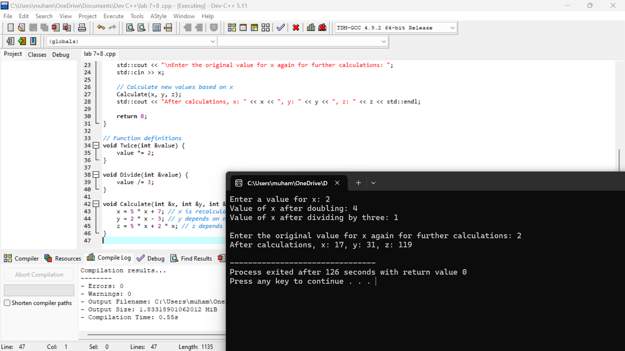

**Task 2:**

Write a C++ program that finds the factorial of a number using recursion.

